Planning Framework

Version: 1.9

Created: April 2019

Updated: June 2019

# Contents

Contents 2

1. Introduction 3

1.1 Background 3

1.2 Purpose 3

2. Drivers for Change 3

2.1 Internal 3

2.2 External 4

2.3 The NHS Long Term Plan 4

3. Planning Guidelines 5

4.1 Levels of Planning 5

4. Managing Change 7

5. Roles and responsibilities 8

6. Benefits from Planning 8

7. Programme Lifecycle 9

7.1 Lifecycle Stages 9

8. Integrated Assurance and Approval Plans (IAAP) 11

Annex 1: IPA IAAP Framework 12

Annex 2: Planning Flow Diagram 13

Glossary of Terms 14

# Introduction

## 1.1 Background

The programme *plan* is the document that allows an overview of the complete picture of a programme, outlining how it is going to work, its structure and its deliverables. It enables strategic level monitoring of dynamic interrelationships between each project and to act when a delay in any one project might jeopardise the work of others.

The Digital Delivery Board (DDB) has responsibility for the control and oversight of Digital Transformation Portfolio and this document has been developed to define the planning process and requirements to support DDB in delivering its commitments.

Programme planning should never be simply a large-scale project plan. Planning a programme requires the amalgamation of various strategies to enable the programme plan to reflect not only the schedule of activities within the programme, but also the way the programme will manage quality, risk, communication and benefits realisation.

Programme planning is recognised as the working model for the business case as well as a management tool, allowing PMs and SROs to keep control of the complex programme they have created. This means that the greatest value can be achieved by starting planning early, especially with regards to investment approvals.

## 1.2 Purpose

The purpose of this document is to outline a consistent approach to planning and reporting against milestones across the Digital Transformation Portfolio (DTP), although the methods set out within this framework can be applied to any programme.

The planning framework sets out to describe a planning *shared language* for understanding programme delivery, irrespective of the delivery style used and enables comparison of different programme types with each other. It is not intended to provide technical or usage instructions on any specific tools.

This planning framework is designed to be used with Agile and Waterfall style deliveries, which enables programmes to link dependencies, transitions and other common elements in a logical and structured way; while also enabling the CCIO portfolio function to oversee delivery of projects and programmes.

# Drivers for Change

## 2.1 Internal

A relatively static portfolio of programmes, in an environment where programmes are initiated and run fundamentally unchanged for the expected period of time, is unlikely to continue for digital health. This model has already started to fracture as the health system moves away from large, waterfall style programmes, to smaller agile developments. In this more dynamic environment there needs to be greater standardisation in planning approaches to give programmes the freedom to deliver while maintaining effective dependency management, reporting and governance.

## 2.2 External

In an environment of limited funding and increasing demands, there are more links and dependencies across programmes; there are also additional reporting demands from outside the system to show what investment is delivering. It is therefore vitally important to provide clarity on progress and this framework will support that.

This framework has been developed taking into account the following documentation.

* The Governance Digital Service Technology Code of Practice (updated Feb 2018)
* The Government Project Delivery Functional Standard (published in Oct 2018)
* The Government Digital Service Standard
* The NHS Digital(?)Planning Standards (produced 2019)
* NHS Long Term Plan (published 2019)

## 2.3 The NHS Long Term Plan

Published in January 2019, the NHS Long Term Plan includes a series of commitments around digital health for the next several years and provides the key driver for change. It is the LTP that will provide the highest level of planning milestones for the DTP in the form of desired outcomes.

# Planning Guidelines

## 3.1 Levels of Planning

Planning takes place at multiple levels of detail within a programme and the types of milestones associated with those different levels are appropriate to the intended audience.

This set of milestones enables:

* A common language for communications across the portfolio and between programmes.
* Interdependencies between programmes to be understood.
* Progress of the portfolio to be managed by the various governance bodies.
* Provides an effective baseline for change control.

### Tier 1

**Type of milestones:** Highest level, start/end, outcomes linked to commitments

**Use**: The planning detail that this level and the milestones included inform are outputs such as Plans on a Page (PoaP) milestones approved by the Digital Delivery Board for the next period. This will include outcomes and key deliverables. Other details at this level will be appropriate Transition to Service milestones, benefits milestones and programme end dates.

### Tier 2

**Type of milestones:** Programme level, key enablers of deliveries and assurance

**Use:** The middle tier of programme planning, will include details on programme delivery, eg transitions between alpha/private beta/pubic beta and into live, key assurance and approval milestones and procurement milestones (where applicable). Many of the milestones at this level may be too detailed for PoaP reporting, but will be vital to showing programme progress (eg delivery increments or benefits milestones) for Programme Boards, Digital Assurance Meetings and external assurance.

### Tier 3

**Type of milestones:** “Project” detail, sprints (or work packages), day-to-day running, Kanban.

**Use:** The final tier of planning revolves around the day-to-day management of individual sprints or work packages. Different approaches and tools may be used at this level such as Kanban boards and less formal management approaches. Individual items form the backlog being delivered in this

How levels of planning milestones work within tiers at different stages within a programme.

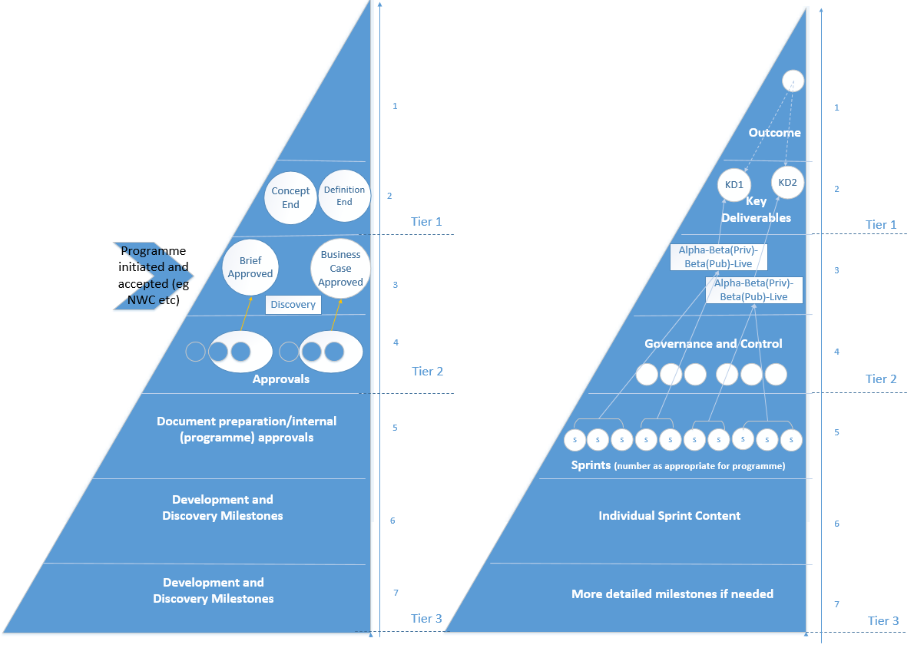

The following table provides guidance on the type of stakeholder group interested in each level of milestones.

|  |  |  |  |  |  |  |  |
| --- | --- | --- | --- | --- | --- | --- | --- |
| **Milestone Level** | Stakeholder Group Interest | | | | | | |
| DDB | CCIO PO | NHSD CPO | Programme Board | Programme Dir / Head / Managers | Project Managers / teams | Project teams |
| **T1 L1** | x | x | x | x | x |  |  |
| **T1 L2** | x | x | x | x | x |  |  |
| **T2 L3** |  | x | x | x | x | x |  |
| **T2 L4** |  |  | x | x | x | x |  |
| **T3 L5** |  |  |  |  | x | x | x |
| **T3 L6** |  |  |  |  |  | x | x |
| **T3 L7** |  |  |  |  |  |  | x |

# Managing Change

The Digital Transformation Portfolio has a separate Change Management Policy, however, changes to milestones are a very important element and there is value in commenting on it within this Framework.

Change is a common and natural part of running a programme, it should not be feared or avoided, but does need to be appropriately managed. The requirements for making changes to milestones very much depend on the Tier in which those changes are being made:

In the third tier, specific dates are likely to change relatively frequently as tasks are resized and better understanding is gained. These changes should be managed within the programme team by the Programme Manager.

In the second-tier changes start to be more impactful. While these changes may not impact the overall delivery of an outcome or even a key deliverable, they may cumulatively have a more significant impact and slippage is frequently an ‘early warning’ of more significant change. The most significant changes with this tier are likely to be those that impact the movement between agile stages (e.g. private to public beta), these changes should be approved by the appropriate Programme Board. There may also be a need to recognise slippages as risks to the delivery of key deliverables or outcomes and reflect these in the appropriate risk system and report them in highlight reports.

In the first tier virtually all changes will require review and approval by the senior governance board, most likely DDB. Many milestones in this tier (e.g. Benefits milestones) will be directly linked to commitments in the LTP or ministerial commitments and will therefore need to be appropriately managed. This should not deter programmes from escalating such issues as the earlier the notice given, the easier these changes are to manage.

# Roles and responsibilities

There are several key roles required to ensure successful implementation of this planning framework:

**Senior Responsible Owner**

The Senior Responsible Owner (SRO) is ultimately accountable for the success of the programme and is responsible for enabling the organisation(s) to exploit the new environment resulting from the programme, meeting the business needs and sign-off plans (including the DTP Plan on a Page) to deliver agreed milestones.

**Product Owner**

This could be the SRO or more likely a different individual who is responsible for defining the features that are needed in the programme, the Product Owner defines the vision, prioritises the backlog, oversees the development stages and anticipates user needs.

**Project Manager/Programme Manager**

PMs are responsible for coordinating all programme/project planning activities. They will develop the overall project / programme plan and contribute to the regular maintenance / updating of the plan in alignment with any relevant change process.

**Scrum Master, Programme PMO/Portfolio Offices and other functions**

The Scrum Master is the person who ensures the team keeps to the values and practices of Scrum; they remove impediments, facilitate meetings and work with product owners. The Scrum Master doesn’t have authority over the team, but does have authority over the process. The PMO and Portfolio support functions help maintain documentation and facilitate upwards reporting (including progress against milestones), be it to Programme Boards or wider governance functions across the system.

# Benefits from Planning

The primary objective for adopting this planning framework is to enable Senior Responsible Owners (SRO), Programme Managers and stakeholders to make informed decisions on their programmes based on factual, up-to-date and accurate data using a shared language across the portfolio.

* The shared language is provided by a common planning language.
* The data is accurate, up-to-date and factual because the common milestones are mapped directly to the plans maintained by the programmes.
* It helps programmes to manage their dependencies on other programmes.
* Enabling programmes to benchmark themselves against other programmes for the purposes of continuous improvement, planning and estimation.

# Programme Lifecycle

A common programme lifecycle provides clarity of activities and assurance for a managed (approved) progression through the life of a programme with resource management and risks over time. In addition, analysis of the lifecycle stages of all programmes within a portfolio also provides a view of the level of maturity.

For the Digital Transformation Portfolio there is a mixture of delivery models in use, both waterfall and agile and so the lifecycle must accommodate those different approaches. The model set out below is ‘book ended’ with common elements that will be consistent regardless of the delivery approach: Concept and Definition at the start of a programme and Closure at the end. The main delivery stage in the middle is where the differentiation between waterfall and agile delivery is most significant.

**Delivery\***

*For fully agile programmes, Design & Develop, Implementation and Transition are all part of a single stage “Delivery” which is sub divided into multiple elements running concurrently.

## 7.1 Lifecycle Stages

**All programmes**

|  |  |
| --- | --- |
| Concept | All programmes (agile or waterfall) go through the **Concept** stage in the same way, as this agrees the **initial scope of new work, approval to begin** and ends with an **approved Brief/IJ** to fund the next stage. |

|  |  |
| --- | --- |
| Definition | All programmes also go through the definition stage which ends with the first Business Case approval, however, some of the activities may differ for Agile vs Waterfall programmes. At the **Definition** stage, Programmes work on defining their **approach**, including confirming the agile/waterfall split and **developing an appropriate Business Case**. Programmes which are running agile are likely to undertake significant **Discovery activity** and may even develop **alphas** to inform the development of the Programme Business Case. |

**Agile**

|  |  |
| --- | --- |
| Delivery | Programmes running agile will start their agile projects (or product, Epic, User Journey etc) which is likely to include additional small spend approvals before further **alphas, private and public beta**.  In practice, this means that programmes running agile, will be at Design & Develop and Implementation at the same time. |

**Waterfall**

|  |  |
| --- | --- |
| Design and Develop | The **Design & Develop** stage is the first with a large split in activity for programmes using waterfall or agile. In this stage programmes running waterfall will **undertake procurement** and submit **an FBC** before contract signing and moving to implementation. |

|  |  |
| --- | --- |
| Implementation | The **Implementation** stage is where **waterfall programmes work with suppliers** to implement the solution. |

|  |  |
| --- | --- |
| Transition | The **Transition** stage focuses on the move to **operations and service management** for both agile and waterfall and marks the point at which the different approaches start to come back together. There is also a need to agree any **benefits management** and ownership going forward. Agile Programmes will go through this step multiple times. |

**All**

|  |  |
| --- | --- |
| Close | The final **Close** stage is around **post implementation reviews** and formal closure of the programme. |

# Integrated Assurance and Approval Plans (IAAP)

As set out in section 3, the Assurance and Approval type milestones will appear in the middle tier of programme planning. Any programme that is appropriately preparing their plans will be able to take a ‘cut’ of those milestones and populate an IAAP.

Why?

An Integrated Assurance and Approval Plan (IAAP) is designed to ensure that suitable assurance activities are thoroughly planned, scheduled and coordinated in advance.

IAAPs are a mandatory requirement for all central government major projects and programmes. Compliance with the agreed IAAP will normally be a condition of HM Treasury approval.

When?

The IAAP should initially be developed at the outset of programmes (in advance of the first Business Case) and moving forward should be fundamental to the overall programme or project plan. Ideally it should form part of the business case.

Who?

Development of the IAAP is the responsibility of the programme or project manager and compliance with it is the responsibility of the SRO. Once agreed, it should be accepted by the programme or project board and subsequently reviewed by the board in the light of any assurance activity undertaken, changes in risk potential or scope of the programme or project.

How?

An example of the framework for IAAP is included as Appendix 2. This reveals the range of assurance and approval activities to consider when building an IAAP – this guidance will be updated further to provide a DTP specific template building on this planning guidance.

# Annex 1 – IPA IAAP Framework

|  |  |
| --- | --- |
| 1. Introduction | * Reference to the corporate IAS (Integrated Assurance Strategy) * What an IAAP is * Why it is required. |
| 1. Purpose and scope | * How the IAAP will be used by the major project team * Scope of the IAAP, including any exclusions or exceptions. |
| 1. Assessment of risks and determination of assurance requirements | * Tools and techniques used to determine risk and focus for assurance activities * Description of how the IAAP has been developed. |
| 1. Roles and responsibilities | * Identify who within the organisation has what responsibilities in relation to assurance and approvals * List of additional key stakeholders and interested parties. |
| 1. Planned assurance coverage and scheduling | * Description of the assurance products to be used * When and why they are to be used. |
| 1. Approvals | * Outline of approvals process within the organisation * Explanation of the assurance evidence which will be required to support approvals at each level. |
| 1. Cost and resources | * Outlined within the business case * Meet TDIB criteria |
| 1. Reporting and communications | * A description of the reporting processes, tools and schedules to be used – both internal and external * Project approach to, and means of, outcomes (whether positive or negative) from assurance activity, both internally and externally * Transparency requirements and commitments in relation to assurance outcomes and reports. * Reports to meet the requirements of Digital Delivery Board (DDB). |
| 1. Managing outcomes, consequential assurance and escalation | * SRO responsibility for implementing the actions and recommendations in assurance review reports * Overall approach to acting on assurance findings * Processes and tools to be used |
| 1. Schedule | * The planned assurance activities for approximately 24 months ahead * Assurance links to approval points and key milestones |

# Annex 2: Planning Flow Diagram

A screenshot of a social media post

Description generated with very high confidence

# Glossary of Terms

|  |  |
| --- | --- |
| Term / Abbreviation | What it stands for |
| ABR | Activity Based Recording |
| Activity | 1. A task defining what needs to be accomplished within a defined period of time. It should have a defined start and end date or a deadline for completion   2. The smallest self-contained unit of work in a project. |
| Agile | A family of development methodologies where requirements and solutions are developed iteratively and incrementally throughout the life cycle in collaboration with the customer ensuring final solution meets business need |
| Baseline | Defines the original scope, cost and schedule. If any change is approved then the new baseline is redefined as the original plan plus the approved change. |
| Breakdown Structure | A hierarchical structure by which project elements are broken down, or decomposed. Examples include:  Cost Breakdown Structure (CBS),  Organisational Breakdown Structure (OBS) should contain responsibilities  Product Breakdown Structure (PBS),  Work Breakdown Structure (WBS). |
| CCN | Change Control Note |
| CPO | NHS Digital Corporate Portfolio Office |
| CCIO | Chief Clinical Information Officer for Health and Social Care |
| Constraint | Constraints are restrictions that affect the project by imposing limitations on costs, resources or project schedule |
| Deliverable | A product, set of products or package of work that will be delivered to, and formally accepted by, a stakeholder. |
| DVP | Deployment Verification Period (to confirm deployment as successful) |
| Milestone | Scheduled event that indicates the completion of a major deliverable event (or a set thereof) of a project. Milestones are measurable and observable and serve as progress markers (flags) but, by definition, are independent of time (have zero duration) therefore no work or consumption of resources is associated with them. |
| MoSCoW | MoSCoW is a prioritisation technique to reach a common understanding on priority of requirements. “Must do”, “Should do”, “Could do” and “Won’t do”. |
| Objective | Predetermined results towards which effort is directed. Objectives may be defined in terms of outputs, outcomes and/or benefits. |
| Outcome | The changed circumstances or behaviour that results from the use of an output. |
| Output | The tangible or intangible product typically delivered by a project. |
| PAR | Project Assessment Review |
| Predecessors | The Predecessors is a pre-activity which the current activity depends on before it can be started or finished. |
| PSDB | Programme and Service Delivery Board |
| PVR | Project Validation Review |
| Resource Plan | Resource plans enables NHS Digital to maximize resource utilisation, balance supply and demand and plan resources over the entire project lifecycle, Service Delivery and Corporate Functions. |
| Resources | Resources which are required to carry out tasks i.e. people, equipment |
| RF | Resource Forecasting |
| RPA | Risk Potential Assessment (used to assess the strategic risk potential of the programme / project.) |
| Schedule | A timetable showing the forecast start and finish dates for activities or events within a project, programme or portfolio. |
| Scrum | A framework within which people can address complex problems while productively and creatively delivering products of the highest possible value |
| SIAM | Service Integration and Management |
| Sprints | A sprint, in Agile software development, is a set period of time during which specific work should be completed and made ready for review. Also known as an ‘iteration’ |
| Successor | An Activity must start or finish before successor tasks can start or finish. |
| Timebox | Timeboxing is used as a project planning technique. The schedule is divided into several separate time periods (timeboxes), with each part having its own deliverables, deadline and budget  The production of project deliverables in circumstances where time and resources, including funding, are fixed and the requirements are prioritised and vary depending on what can be achieved within the timebox. |
| Waterfall | The Waterfall model is a sequential design process, used in software development processes, in which progress is flowing steadily downwards (like a Waterfall) through the project lifecycles. |